**[This](https://github.com/udacity/reactnd-UdaciFitness-complete/tree/78a78135ab80b78e8585f428052e76573fc8996e" \t "_blank)** is where we left off in the last lesson.

React Native's version of Local Storage is AsyncStorage.

AsyncStorage is:

* asynchronous
* Javascript abstraction over the iOS and Android equivalents
* 3 main methods: setItem(), removeItem(), and clear()

**[[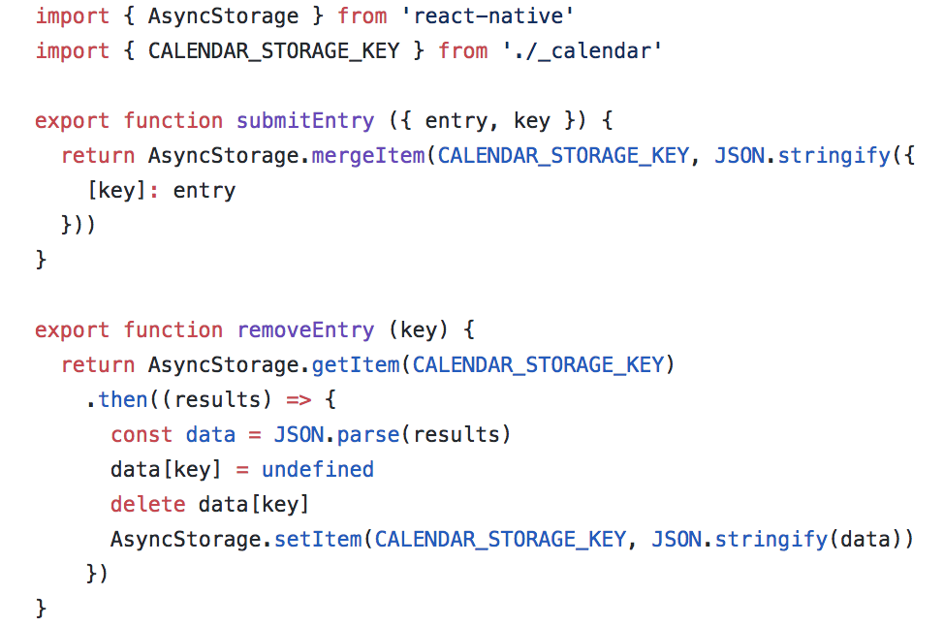](https://classroom.udacity.com/nanodegrees/nd019/parts/1187639a-82e2-4dd8-9d7b-477af14e5dd7/modules/03dca13b-c006-4b08-b470-c5e72699fb01/lessons/e14caec8-695e-48db-ac2b-894e8e5f52de/concepts/d241e065-cdc4-4a14-b6cf-13efc0804c1b)](https://classroom.udacity.com/nanodegrees/nd019/parts/1187639a-82e2-4dd8-9d7b-477af14e5dd7/modules/03dca13b-c006-4b08-b470-c5e72699fb01/lessons/e14caec8-695e-48db-ac2b-894e8e5f52de/concepts/d241e065-cdc4-4a14-b6cf-13efc0804c1b)**

**[Adding and Removing Entries](https://classroom.udacity.com/nanodegrees/nd019/parts/1187639a-82e2-4dd8-9d7b-477af14e5dd7/modules/03dca13b-c006-4b08-b470-c5e72699fb01/lessons/e14caec8-695e-48db-ac2b-894e8e5f52de/concepts/d241e065-cdc4-4a14-b6cf-13efc0804c1b)**

CALENDAR\_STORAGE\_KEY is where we're going to persist the information inside of our AsyncStorage.

When we're adding a new entry, we merge the new object into the CALENDAR\_STORAGE\_KEY property on AsyncStorage.

When we're moving an entry, we first get everything at the CALENDAR\_STORAGE\_KEY location. Then, delete the data we no longer need. Then, we stringify the modified data object and put it in AsyncStorage.